WDTC Document No. WDTC-TR-99-081

Final Report

For the

EXPEDIENT PERSONNEL DECON PROCEDURE VALIDATION

MICHAEL J. GLASS
DAVID H. BROWN
VINCENT M. LIDDIARD

SPECIAL PROGRAMS DEVELOPMENT
WEST DESERT TEST CENTER

West Desert Test Center
Dugway Proving Ground

Dugway UT, 84022

October, 1999

Contents

EXPEDIENT PERSONELL DECON PROCEDURE VALIDATION 1
Table of Contents 2
Introduction 3
Materials and Methods 3
Tinopal Simulant Solution 3
Results 5
Contamination Density 6
Tinopal Inactivation 7
Phase I: Baseline Study 7
The ensembles and iterations used in the second baseline study are summarized in the following table. 7
Discussion 22

Figures

Figure 1. Tinopal spray patterm 7
Figure 2The following photo set (figure 2a through h) illustrates the application of the Tinopal/sucrose simulant solution to the two piece GORTEX/CPU ensemble worn by the test subjects. 11
Figure 3The following photo set (Figure 3a through h) depicts Type VII ensemble two-piece cut-out procedures. 13
Figure 4 The following photo set (figure 4a –f) depicts FRIS/CPU with tag ensemble one piece cut-out. 15
Figure 5The following photo set (Figure 5a-f) depicts the FRIS/CPU without tag one piece ensemble cut-out. This iteration was inserted into the validation study to verify that the “contamination” detected on the lower backs of some test participants was due to the leeching of fluorescent dye from the laundry tags of the CPU garments. 17
Figure 6 The following photo set (Figure 6a-g) depicts the Dry Suit one piece ensemble cut-out. 19
Figure 7. The following photo set (Figure 7a-g) depicts the Litter Decon cut out. 21
Figure 8. Per-man iteration times for all ensembles. 22

Tables

Table 1. Lower Limits of Detection of Tinopal Solution……………………………………………………5
Table 2. Proof of Concept (Baseline) Ensemble Constituents. 8
Table 3. Ensemble Constituents of ‘Contaminated’ Personnel and (Cutter) Decon Personnel. 9
Table 4. Results of ‘CPU/GORTEX’ Ensemble Cut-Out Procedure. 10
Table 5. Results of ‘Type VII’ Ensemble Cut-Out Procedure. 12
Table 6. Results of ‘FRIS/CPU [w/tag]’’ Ensemble Cut-Out Procedure. 14
Table 7. Results of ‘FRIS/CPU [wo/tag]’ Ensemble Cut-Out Procedure. 16
Table 8. Results of ‘DRY Suit’ Ensemble Cut-Out Procedure. 18
Table 9. Results of ‘Litter Decon’ Cut-Out Procedure. 20

Introduction
The objectives of this validation were to develop and prove that an expedient decontamination procedure would eliminate the possibility of cross contamination of personnel during physical removal of contaminated protective ensembles. This validation was designed to qualitatively measure cross contamination from a liquid challenge during a novel expedient decon procedure developed by NSWDG. Traditional decon methods are not suited to the mission needs of the SOF community based upon logistical burdens.
The scope of this study was limited to liquid challenge hazard because it represents the predominant source of cross contamination. This study does not take into account the effects of vapor off-gassing during cut-out procedures because it does not represent a source of cross contamination. While not eliminated, the vapor hazard is significantly mitigated by use of Sorbent decon and immediate isolation of contaminated articles. During the course of this study, the decontaminants used were not tested for their effectiveness against given agents. We relied upon AMC test results that indicate these products inactivate or absorbed chemical warfare agents.
Of the six iterations of validation trials and eight iterations of procedure development (baseline studies), no incidence of liquid cross contamination due to procedure was noted. Early indications of lower back exposure to simulant following cut-out procedures (CPU/Gortex and Fris/CPU) were later attributed to the leeching of fluorescent dye (see explanation below) from the laundry tags attached to the CPU bottoms and tops. Therefore, of the 94 (46 for baseline, 48 for validation) individuals processed through NSWDGs cut-out procedure, the lack of cross contamination of simulant G agent served to validate both the one-piece and two-piece ensemble expedient personnel (ambulatory and non-ambulatory) decon procedure (described below) for a liquid challenge.

Materials and Methods

Tinopal Simulant Solution
The base simulant solution (G agent simulant) used for this study was a mixture consisting of 10% (w/v)of sucrose in distilled water. To this was added 0.06% Tinopal (w/v ) (Tinopal-CBS, Tilley Chemical Company) as a fluorescent marker. This solution mimicked some of the physical properties of nerve agents (viscosity and droplet size) but did not mimic the liquid persistency of VX. However, it was demonstrated that even upon drying, the simulant portrayed a contact hazard and the ability to cross-contaminate upon touch. Therefore, this was an ideal solution for the determination of cross-contamination during expedient exfiltration of personnel.
Previous studies have indicated that a one pump spray (from a [DPG equipment] Tinopal spray bottle) consisted of approximately 1 cc of liquid that weighed 1 gram. Experimentation was conducted to determine the contamination density from one (one-pump) application. The solution was sprayed onto Whatman paper from a distance of 88 cm and the diameter of the spray pattern was measured. By calculating the area of the spray pattern, the density of contamination was determined. To increase accuracy and reliability, this experiment was completed with eight iterations. The simulant mixture was used to contaminate the individuals and equipment by spraying 20 pumps (to approximate 10gram/m² challenge) with a one quart pump spray bottle. To assess cross-contamination by cut-out procedure, the test participants were undressed and photographed under blacklight conditions to determine inherent fluorescence associated with lint, body hair, scars etc... Once individuals were suited up into the respective ensembles, they were exposed to Tinopal and again photographed under blacklight (see Figure 1 below). Following cut-out procedures, the individuals were photographed and assessed for Tinopal contamination due to the cut-out procedures.

One Piece Cut-out Standard Operating Procedure
- Remove Mk1 medical kits
- Remove M291 and M295 and place at hot line
- Full body ‘buddy’ decon (patting down) using M295
- Proceed into first shuffle pit containing decontaminate. Decon feet/boots.
- Proceed to second shuffle pit. While in pit, cut straps off hood, lossen neck cord. Cutter decon hands and cutting utensils. Roll hood from rear bottom and gather bottom into neck cord. Cutter decon hands and cutting utensils.
- Cut wrist, waist, and ankle closures on PPE. Cutter decon hands and cutting utensils. Release cut boot closures. Cutter decon hands and cutting utensils.
- Remove boots. Cutter decon hands and cutting utensils.
- Cut back of PPE down one leg as far as possible. Cutter decon hands and cutting utensils. Cut down other leg from buttocks area. Cutter decon hands and cutting utensils.
- Remove suit forward, stripping down and fold the suit into itself. Remove gloves with the garment. Cutter decon hands and cutting utensils.
- (CPU removal) Cut down middle of back. Cutter decon hands and cutting utensils.
- Extend arms forward and pull CPU top down arms folding CPU garment into itself. Cutter decon hands and cutting utensils.
- Cut down outer side of each leg and have deconee step forward out of garment. Cutter decon hands and cutting utensils.
- Strip of outer sock, then inner sock with deconee stepping directly onto safety pad (impregnated with decontaminate). Cutter decon hands and cutting utensils.
- Proceed to mask drop area. Decon deconee’s hands and remove mask by pulling crown tag on mask (utilizing breath hold technique with assisted mask removal). Cutter decon hands and cutting utensils.
- Move to redress area, redress, move to exfil area.

Two piece Cut-out Standard Operating Procedure
- Remove Mk1 medical kits
- Remove M291 and M295 and place at hot line
- Full body ‘buddy’ decon (patting down) using M295
- Proceed into first shuffle pit containing decontaminate. Decon feet/boots.
- Proceed to second shuffle pit. While in pit, cut straps off hood, lossen neck cord. Cutter decon hands and cutting utensils. Roll hood from rear bottom and gather bottom into neck cord. Cutter decon hands and cutting utensils.
- Cut wrist, waist, and ankle closures on PPE. Cutter decon hands and cutting utensils.
- Cut top rear center down back of garment. Cutter decon hands and cutting utensils.
- Extend arms forward and pull top down arms folding garment into itself. Cutter decon hands and cutting utensils.
- Cut down outer side of each leg and have deconee step forward out of garment. Cutter decon hands and cutting utensils.
- Cut boot closures, cutter secure boot and deconee step forward out of boots. . Cutter decon hands and cutting utensils.
- (CPU removal) (CPU removal) Cut down middle of back. Cutter decon hands and cutting utensils.
- Extend arms forward and pull CPU top down arms folding CPU garment into itself. Cutter decon hands and cutting utensils.
- Cut down outer side of each leg and have deconee step forward out of garment. Cutter decon hands and cutting utensils.
- Strip of outer sock, then inner sock with deconee stepping directly onto safety pad (impregnated with decontaminate). Cutter decon hands and cutting utensils.
- Proceed to mask drop area. Decon deconee’s hands and remove mask by pulling crown tag on mask (utilizing breath hold technique with assisted mask removal). Cutter decon hands and cutting utensils.
- Move to redress area, redress, move to exfil area.

Results

Tinopal Detection Limits
In an effort to define the operational meaning of “clean” using the Tinopal system, we completed a set of experiments to understand the limits of detection of the fluorescent dye. From this data and knowing the concentration of Tinopal in our solution and LD₅₀ of VX, we equated the Tinopal LLD (lower limits of detection) to a comparable VX contamination. This experiment has several inherent assumptions; 1) the Tinopal solution would act in a similar manner to VX (the Tinopal solution was made so that the viscosity was similar to VX). 2). Using the naked eye and UV lights (280nm wavelength) as our assay, variability will exist in this system (we attempted to minimize this by doing 10 fold dilutions of our solution and using seven people to gauge the results).
The experimental design was to create 10-fold dilutions of the Tinopal solution (10% sucrose and 0.06% Tinopal) from 1 to 10⁻⁴ in 10% sucrose/water. A known volume (100μl) of these solutions were then applied to filter paper and assayed by the naked eye under the same black light system used in the baseline study. The highest dilution where a signal could be identified was determined as the LLD. A negative control (10% sucrose/water) and a positive control (1x concentration of Tinopal solution) verified the validity of the assay system.
From this experiment, it was determined that the LLD was a 10⁻² dilution of the Tinopal solution. Previous measurements determined that this would equate to approximately 1mg of liquid contamination. The LD₅₀ for percutaneous application of VX is 10 mg/70 kg (50 mg/70kg GD, 30 mg/70kg GF, 1000mg/70kg GA, 1700mg/70kg GB, [U.S. Army Medical Research Institute of Chemical Defense (USAMRICD) "Medical Management of Chemical Casualties Handbook"]). Therefore, in this system, the LLD of the Tinopal solution is approximately 10-fold less than the LD50 for a 70 kg person. Once again, it should be noted that this does not take into account the vapor hazard from VX contamination.
In a similar experiment, the detection limit was determined by dropping undiluted Tinopal solutions of known volume on the Whatman paper. This test would eliminate the potential for the loss of visible signal due to dilution in the sugar water mix. However, the series of tests are limited by the accurate placement of a known volume. Therefore, the range for this test was undiluted Tinopal volumes of 100 μl, 10μl 1μl, 0.1μl. For a more accurate representation of the data, the experiment was run with eight replicates and included a sugar water negative control. The results from this series of tests showed that the Tinopal solution could be observed even at the lowest volume placed on the paper (equivalent to a 10-3 reduction of volume). This indicated that the LLD for the Tinopal solution was even 10 fold greater than determined from the previous experiment. Therefore, using the calculations above, the LLD for this taggant simulant is approximately 100-fold less than the LD50 of VX for a 70kg person (Table 1).

Table 1. Lower Limits of detection of Tinopal solution.

The first percutaneous symptoms for HD appear as erythema at 10μg/70Kg (the LD50 is 40-50mg/Kg which equates to 3500 mg/70 Kg person). Using these limits and the calculated LLD for the Tinopal solution, this system would detect to a limit that was 10 fold above the first percutaneous symptoms for HD. It should be noted however, that the simulant system would detect 35,000-fold below the lethal dose of HD.

Contamination Density
As described in the materials and methods, the density of the contamination was measured for this validation. The calculations determined that each spray pattern covered approximately 0.065 m² (σ = 0.0088, CV = 13.5%). From this it was calculated that at a distance of 88 cm (used in the validation) each spray resulted in a localized contamination density of 15 grams/ m². When averaged over the approximate area of an individual (2 m²), the average contamination density/individual was 10 grams/ m².
Figure 1. Tinopal spray patterm
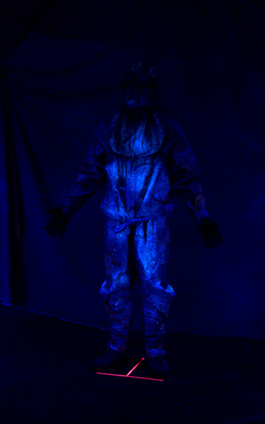

Tinopal Inactivation
One critical aspect of this simulant system for use in determining the efficacy of a given procedure is the ability of the various decontaminates to inactivate or neutralize the fluorescent signal. The decontaminates used in this series of tests included: 5% sodium hypocholrite (household bleach), M295 resin and SDS resin (Sorbent Decon System [see attached MSDS]). The decon solutions were used to test their effectiveness against both the wet and dried Tinopal solution. The Tinopal solution was applied to a variety of surfaces (hard porous, cloth material and skin) and treated with the decons material. From this analysis it was determined that the bleach and M295 neutralized the fluorescent signal in both a wet and dry simulant form. However, while the SDS neutralized the wet Tinopal solution rapidly, the neutralization was slowed when the Tinopal solution was allowed to dry. In this system, the SDS did minimize the transfer (cross-contamination) of the dried Tinopal solution and was useful for the validation studies conducted. DPG continues to analyze the effects of the various decontaminates on the physical properties of the different tinopal compounds and their relationship to the effects of the decontaminates on the various WMD agents.

Phase I: Baseline Study
The objectives of the baseline study were to utilize the existing decon solutions (hypochlorite – liquid decon) and refine ‘proof of concept’ and verify the reliability of the expedient decon exfiltration method. DPG and NSWDG personnel at NSWDG command conducted the original baseline study. This study (consisting of a liquid simulant challenge with fluorescent tag served to point out concerns with the decontamination cut-out procedure drafted by NSWDG. A follow-up developmental study (under similar conditions) was conducted the week of 17 June 1999 at WDTC, DPG to further refine procedures. These proof of concept results were then applied to a phase II validation study conducted at WDTC, DPG the week of 8 August, 1999.
It should be noted that the selection of surrogates was to mimic one and two-piece protective ensembles for training and development of mechanical cut-out procedures. These surrogates were not selected for their (liquid) chemical protective qualities. For the baseline trials, liquid decontaminate (Sodium Hypochlorite), M295 and mechanical decontamination methods were employed. Of the 46 trials, there was one incidence of self cross contamination where an individual touched a clean body surface with a contaminated-gloved hand. No incidences of cross contamination due to procedure were observed. The successful development of these Phase I procedures provided the basis for validation in Phase II.

The ensembles and iterations used in the second baseline study are summarized in the following table.

Table 2. Proof of Concept (Baseline) Ensemble Constituents.
 | Test #1 | Test # 2 | Test # 3 | Test # 4 | Test # 5 | Test # 6 | Test # 7 A/B
Ensemble | Gortex | DBDU | Fris Suit | Dry Suit | JSLIST Type VII | DBDU | one (A) piece two (B) piece
Running Shorts | X | X | X | X | X | X | X (A/B)
Smart (wool) socks
Gortex Socks |  |  |  |  | X | X | X (A/B)
CPU Sock (smart wool Surrogate) | S | S | S | S | S | S | S (A/B)
CPU Bottom (therm underwear=Surrogate) | S | S | S | S |  | S | S (A)
CPU Top (therm underwear=Surogate) | S | S | S | S |  | S | S (A)
Gortex Bottom Saratoga=Surrogate | S
Gortex Top Saratoga=Surrogate | S
JSLIST Type VII |  |  |  |  | X |  | X (saratoga=surr)
DBDU Bottom |  | X |  |  |  | X
DBDU Top |  | X |  |  |  | X
FRIS |  |  | X |  |  |  | X (Dry Suit surr)
DRY Suit |  |  |  | X
Boot of Choice | X | X | X |  | X | X | X (A/B)
Butyl Rubber Glove | X | X |  |  | X | X
DUI Glove |  |  | X | X
M45 | X | X | X | X | X | X | X (A/B)
Butyl Rubber Hood= MCU2P Surrogate | S | S | S | S | S | S | X (A/B)
Notes | 8 personnel, including 2-man decon team with decon line close out | 6 personnel | 8 Personnel | Dry Suit (DUI) | 8 personnel | 8 personnel, 6 with 2-man decon team close out | Two runs-4 one-piece (A) using flight suit surrogate, 4 two-piece (B) using flight suit surrogate-hood removed
S denotes use of surrogate clothing item.

Phase II: Validation of Procedures
Based upon results obtained from the developmental Phase I study, the validation study was conducted at WDTC, DPG the week of 8 August 1999. Prior to the timed validation results listed below was a period of training to orient the participants to the procedures. The average time of training per individual was 8 hours. Since there has not been an effort to optimize training efficiency to date, 8 hours represents the maximum period of time to master the procedures to these levels. The ensembles validated in Phase II constitute the Personal Protective Equipment currently employed by Special Operations Forces. The following table lists the constituents of the different ensembles used in the decontamination cut-out procedures.

Table 3. Ensemble Constituents of ‘Contaminated’ Personnel and (Cutter) Decon Personnel.
Ensemble | Gortex/CPU | Type VII | FRIS/CPU | FRIS/CPU | Dry Suit | Litter Decon | Cutters
 |  |  | w/ tag | wo/tag
Running Shorts | X | X | X | X | X | X | X
Smart (wool) socks | X | X | X | X | X |  | X
Gortex Socks | X | X |  |  | X | X
CPU Sock |  |  |  |  |  | X
CPU Bottom | X |  | X | X | X
CPU Top | X |  | X | X | X
Gortex Bottom | X
Gortex Top | X
JSLIST Type VII |  | X |  |  |  | X
Saratoga |  |  | X | X |  |  | X
FRIS |  |  |  |  | X
DRY Suit
Flight Suit | X | X
Adidas Boot |  |  |  |  |  |  | X
Other' Boot |  |  | X | X
Vans | X | X | X | X |  | X | X
Butyl Rubber Glove |  |  |  |  | X
CPU Glove | X | X | X | X | X | X | X
M45 | X | X | X | X | X | X
2nd Skin Hood | X | X | X | X | X | X | S
Butyl Rubber Hood

Table 4. Results of ‘CPU/GORTEX’ Ensemble Cut-Out Procedure.

Personnel | Pre-exposure | Ensemble | Contamination | Time Through Line (min)
(10) | None | CPU / GORTEX / 2nd Skin Hood | Clean* | 13
(16) | RT medial wrist | " | Clean* | ND
(2) | Charcoal on back | " | Clean* | ND
(8) | Frt. Shorts, Lft Rear,Dorsal Lft hand | " | Clean* | ND
(5) | Lft knee, Lft elbow | " | Clean | 15
(3) | Tinea Rt abdom, Rt thigh | " | Clean | 15
(15) | Rt thigh, Rt upper back | " | Clean | 17
(12) | Rt foot | " | Clean | 14
 |  |  |  | Avg: 14.8 Min
Cutters |  |  |  | Total Iteration Time: ND
(7) | None | Flt. Suit/BR gloves/Sk/Bt/M45 w/BR Hood | Clean
(13) | None | " | Clean
(11) | None | " | Clean
(6) | None | " | Clean
Decon Result (I.e. 'clean'):
w/o cutters 100%
 |  |  | w/ cutters 100%

Clean* denotes contamination due to leeching of fluorescent dye for the laundry tags of the CPU garments (both situated at lower back). Initial contamination on the lower backs of the noted individuals was later experimentally determined to be the result of the tags (see results below).
Figure 2The following photo set (figure 2a through h) illustrates the application of the Tinopal/sucrose simulant solution to the two piece GORTEX/CPU ensemble worn by the test subjects.
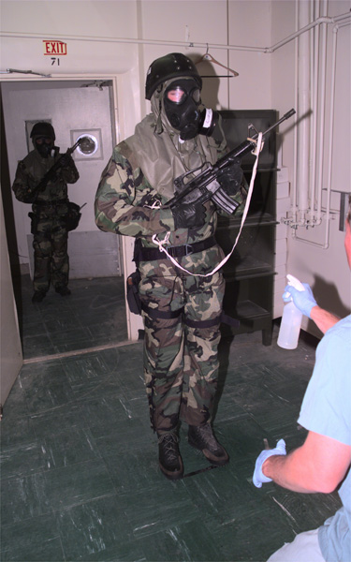 | 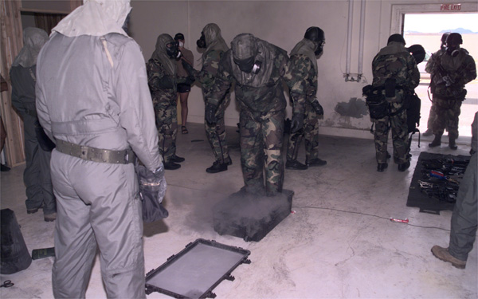
A. Application of Tinopal | B. Shuffle Pit Procedure
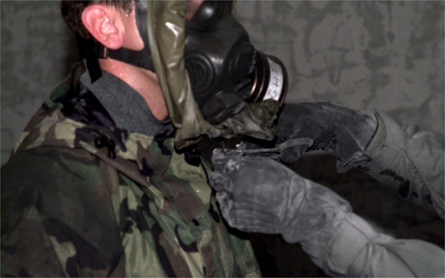 | 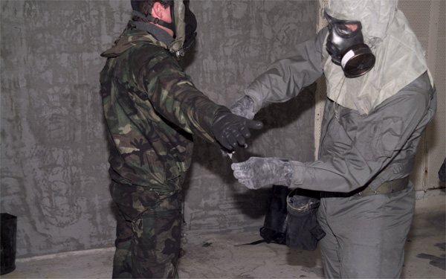
C. Rolling/securing of Mask Hood | D. Cut-out of outer garment #1
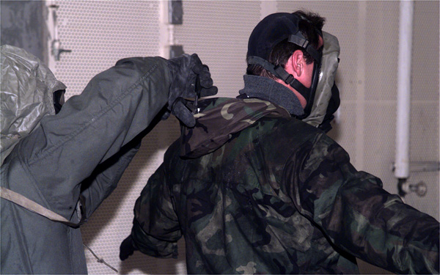 | 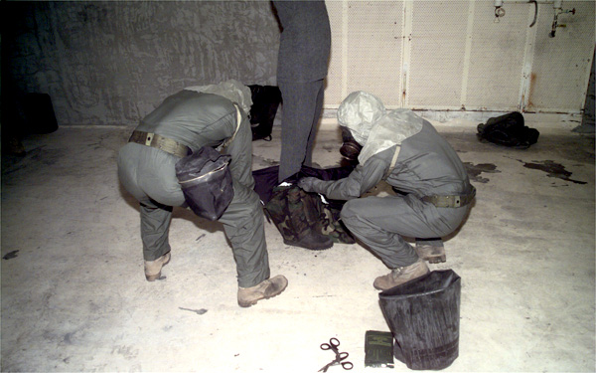
E. Cut-out of outer garment #2 | F. Cut-out of outer garment #3
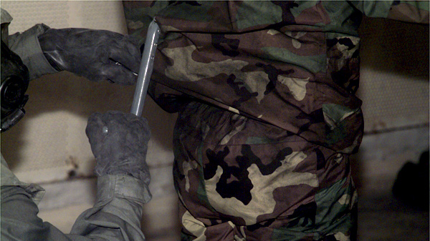 | 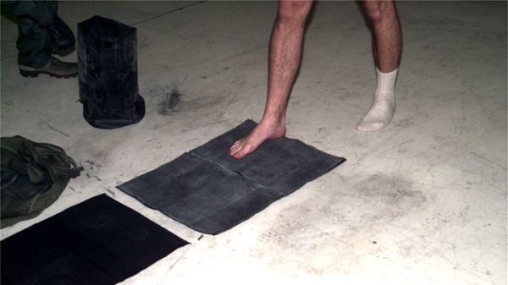
G. Cut-out of outer garment #4 | H. SDS Mat

Table 5. Results of ‘Type VII’ Ensemble Cut-Out Procedure.

Personnel | Pre-exposure | Ensemble | Contamination | Time Through Line (min)
(3) | none | TypeVII / 2nd Skin Hood | Clean | 9
(7) | none | " | Clean | 12
(6) | none | " | Clean | 12
(12) | none | " | Clean | 11
(1) | none | " | Clean | 10
(8) | none | " | Clean | 10
(2) | none | " | Clean | 8
(4) | none | " | Clean | 12
 |  |  |  | Avg. 10.5 min
Cutters |  |  |  | Total Iteration Time: 37 Min
(5) | none | Flt. Suit/BR gloves/Sk/Bt/M45 w/BR Hood | Clean
(11) | none | " | Clean
(6) | none | " | Clean
(2) | none | " | Clean
Decon Result (I.e. 'clean'):
w/o cutters 100%
 |  |  | w/ cutters 100%

Figure 3The following photo set (Figure 3a through h) depicts Type VII ensemble two-piece cut-out procedures.
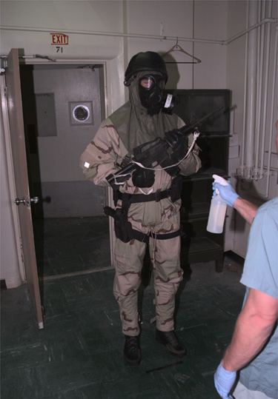 | 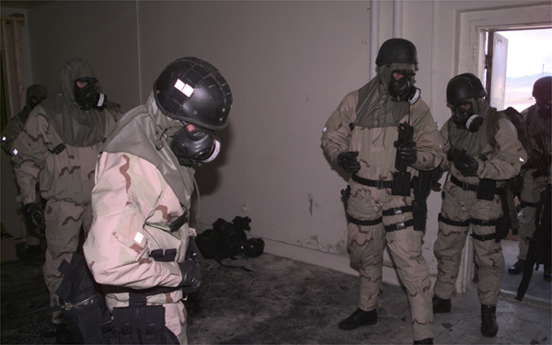
A. APPLICATION OF TINOPAL | B. REMOVAL OF GEAR
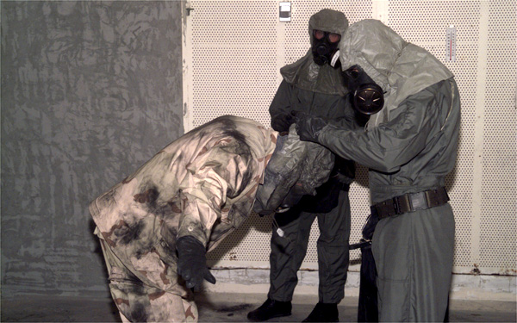 | 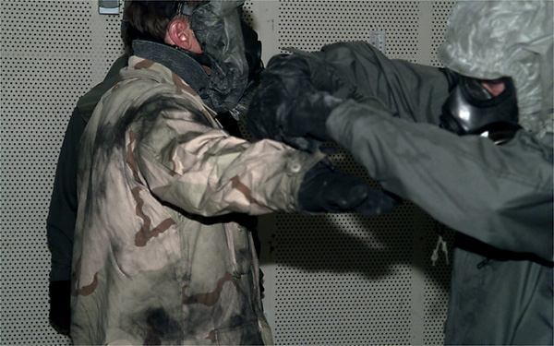
C. MASK HOOD ROLL | D. MASK HOOD SECURE PROCEDURE
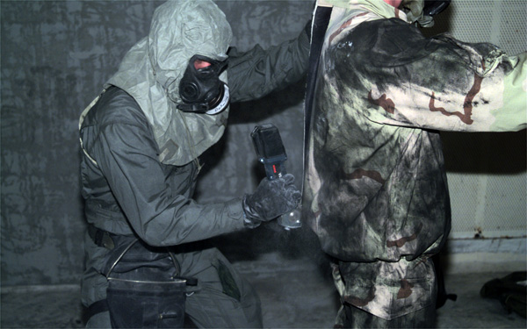 | 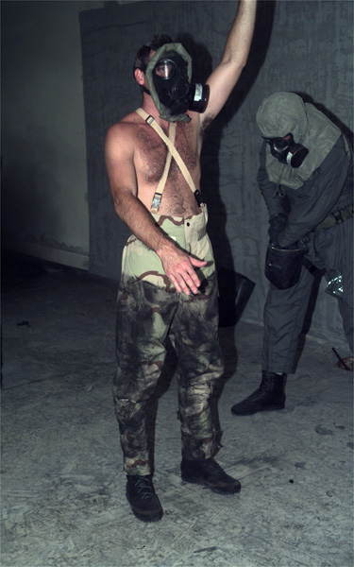
E. OUTER GARMENT CUT-OUT #1 | F. OUTER GARMENT CUT-OUT #2
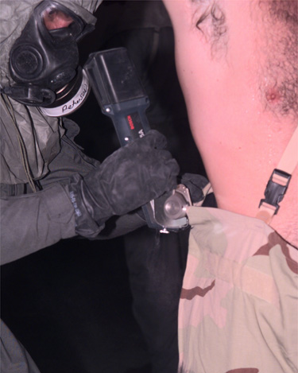 | 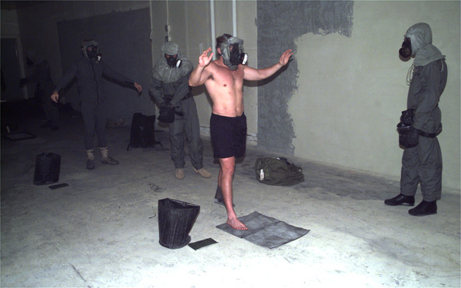
G. OUTER GARMENT CUT-OUT #3 | H. SDS MAT
Table 6. Results of ‘FRIS/CPU [w/tag]’’ Ensemble Cut-Out Procedure.
Personnel | Pre-exposure | Ensemble | Contamination | Time Through Line (min)
Mummert (2) | None | FRIS/CPU [with tag] / 2nd Skin Hood | clean | 12
Gehosky (3) | None | " | Clean | 11
Wilkens (1) | None | " | Clean | 12
Harty (8) | None | " | Clean | 10
Voight (5) | None | " | Clean | 11
Swanson (16) | None | " | Clean* | 12
Peterson (17) | None | " | Clean | 12
Maddocks (12) | None | " | Clean* | 11
 |  |  |  | Avg. 11.4 Min
Cutters |  |  |  | Total Iteration Time: 44 Min
(a) | None | Flt. Suit/BR gloves/Sk/Bt/M45 w/BR Hood | Clean | NA
(b) | None | " | Clean | NA
(c) | None | " | Clean | NA
(d) | None | " | Clean | NA
Decon Result (i.e. 'clean'):
w/o cutters 75%
 |  |  | w/ cutters 83%

Clean* denotes contamination as a result of CPU tag leeching.
Figure 4 The following photo set (figure 4a –f) depicts FRIS/CPU with tag ensemble one piece cut-out.
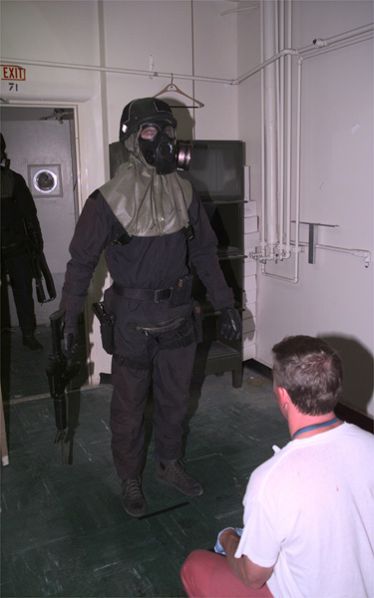 | 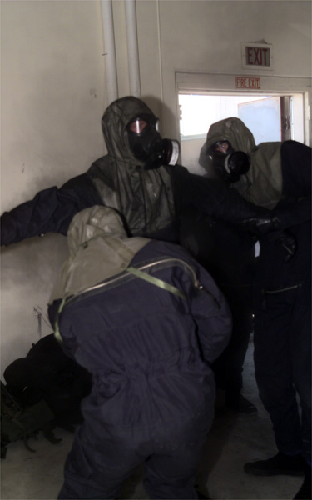
A. Tinopal application | B. M295 APPLICATION
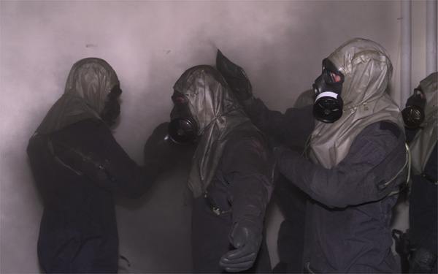 | 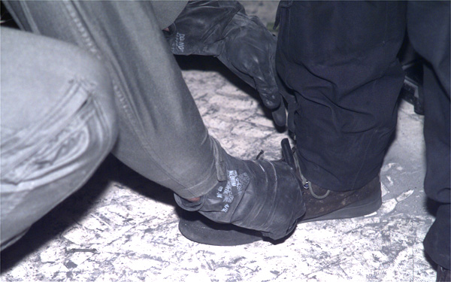
C. M295 application | D. cutting of boot strap
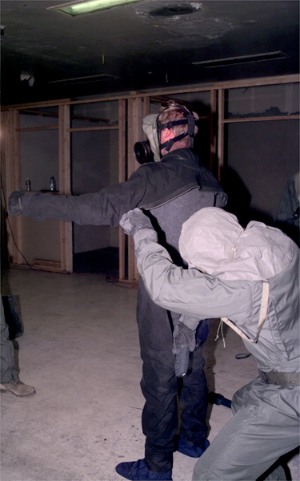 | 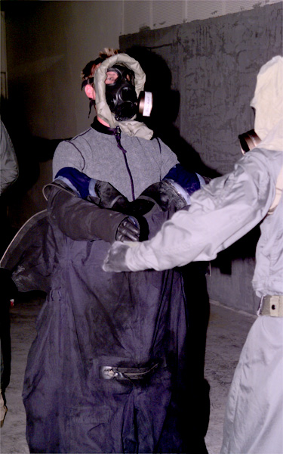
E. OUTER GARMENT CUT-OUT #1 | F. OUTER GARMENT REMOVAL

Previously, ‘contamination’ was noted on several individual’s lower back following cut-out of the Gortex/CPU ensemble. That phenomenon was again noted with the FRIS/CPU ensemble cut-out as well. We determined that the FRIS suit, alone, was impervious to the liquid simulant under passive and ‘under pressure’ challenges. The same challenges were earlier presented for the Gortex material. Results from the passive and ‘under pressure’ challenges of this material proved to be inconclusive, but suggest that bleed through of simulant under the demonstrated loads (operator gear) was unlikely. Due to these data, a separate qualitative experiment was conducted to determine if the fluorescent dye contained within the laundry tags from the CPU garments were leeching onto the test participant’s backs via perspiration. CPU laundry tags were cleanly removed (without skin contact) from previously unworn garments and placed in either 200 mls of double distilled water or in (pH 7.0) Phosphate Buffered Saline (PBS) at ambient (75º F) temperature. Tags were incubated in water or saline for 30 minutes and then removed. The water and saline were then observed under standard black light conditions to qualitatively determine if fluorescent dye had leeched from the tags. Incubation of the tags in water did not induce leeching. Incubation of the tags in PBS (sweat surrogate) produced considerable leeching of dye. To confirm that the CPU tag dyes were the cause of ‘contamination’ of the test participants, the garments that had tags removed were then used for the following iteration (FRIS/CPU without tags). As predicted, individuals exposed to similar simulant levels and outfitted with similar gear (as with FRIS/CPU with tags) did not have evidence of cross contamination or penetration of simulant through their protective (FRIS/CPU) ensemble.

Table 7. Results of ‘FRIS/CPU [wo/tag]’ Ensemble Cut-Out Procedure.

Personnel | Pre-exposure | Ensemble | Contamination | Time Through Line (min)
(16) | None | Fris/CPU [without tag] / 2nd skin hood | Clean | 11
(12) | None | " | Clean | 12
(5) | None | " | Clean | 9
(8) | None | " | Clean | 10
(1) | None | " | Clean | 12
(6) | None | " | Clean | 13
(17) | None | " | Clean | 11
(2) | None | " | Clean | 9
 |  |  |  | Avg. 10.9 Min
Cutters |  |  |  | Total Iteration Time: 40 Min
(5) | None | Flt. Suit/BR gloves/Sk/Bt/M45 w/BR Hood | Clean
(11) | None | " | Clean
(6) | None | " | Clean
 | None | " | Clean
Decon Result (i.e. 'clean'):
w/o cutters 100%
 |  |  | w/ cutters 100%

Figure 5The following photo set (Figure 5a-f) depicts the FRIS/CPU without tag one piece ensemble cut-out. This iteration was inserted into the validation study to verify that the “contamination” detected on the lower backs of some test participants was due to the leeching of fluorescent dye from the laundry tags of the CPU garments.
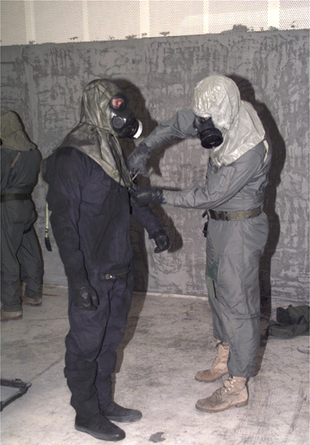 | 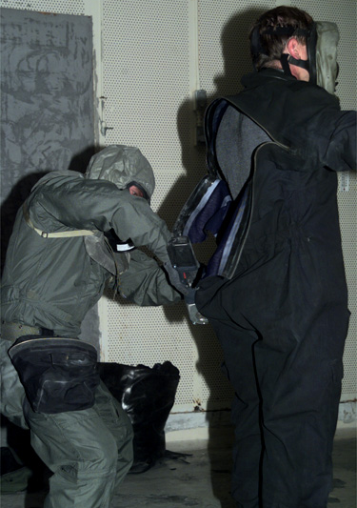
A. Cutting of hood strap | B. Cutting of FRIS
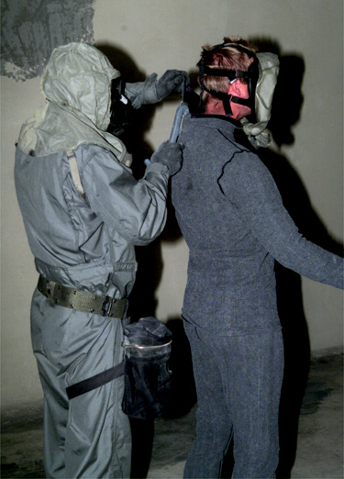 | 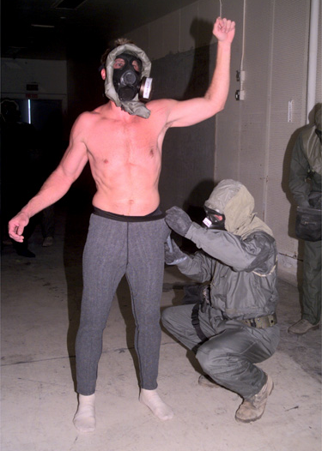
C. Top down cut of upper CPU | D. Top down cut of lower CPU
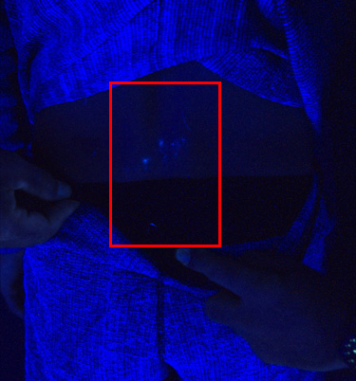 | 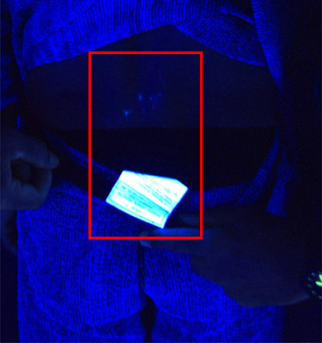
E. "Contamination" from CPU tag | F. Fluorescent properties of tag
Table 8. Results of ‘DRY Suit’ Ensemble Cut-Out Procedure.

Personnel | Pre-exposure | Ensemble | Contamination | Time Through Line (min)
Wilkins | None | Dry Suit/CPU [w/o tags] | Clean | 14
Woods | None | " | Clean | 15
Mummert | None | " | Clean | 13
Peterson | None | " | Clean | 11
Swanson | None | " | Clean | 12
Traber | None | " | Clean | 12
Harty | None | " | Clean | 13
Voight | None | " | Clean | 11
 |  |  |  | Avg. 12.6 Min
Cutters |  |  |  | Total Iteration Time: 41 Min
#1 | None | Flt. Suit/BR gloves/Sk/Bt/M45 w/BR Hood | Clean
#2 | None | " | Clean
#3 | None | " | Clean
#4 | None | " | Clean
Decon Result (i.e. 'clean'):
w/o cutters 100%
 |  |  | w/ cutters 100%

Figure 6 The following photo set (Figure 6a-g) depicts the Dry Suit one piece ensemble cut-out.
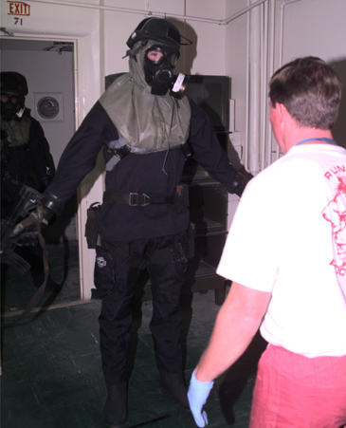 | 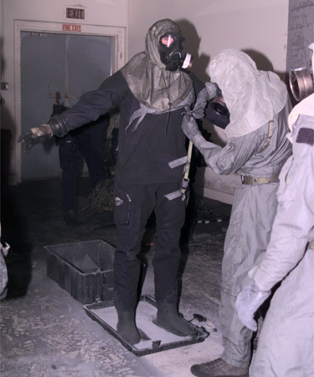
A. Tinopal Application | B. Cutting of hood strap
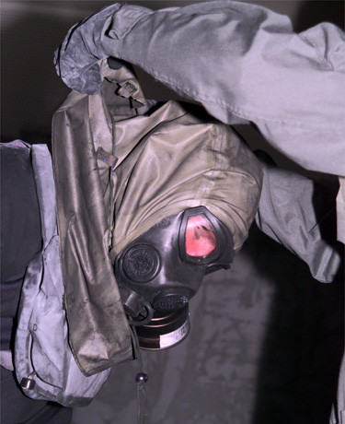 | 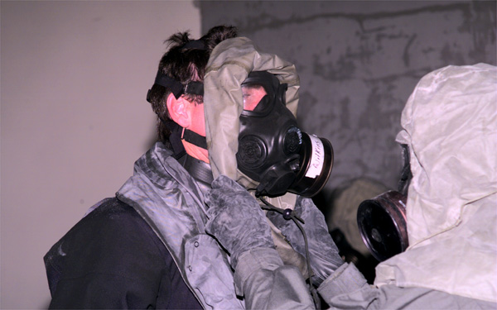
C. Rolling of hood | D. Securing of hood
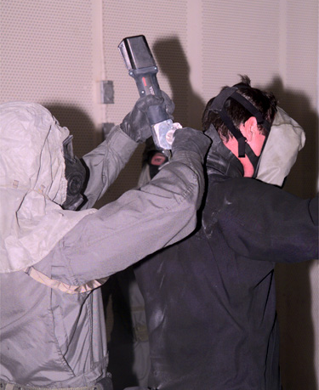 | 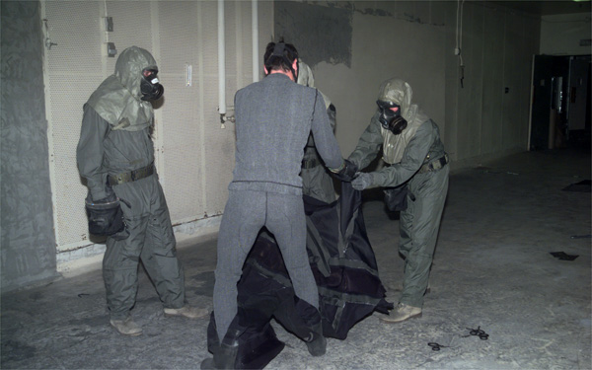
E. Top down cut of Dry suit | F. Dry suit removal "stepping out."
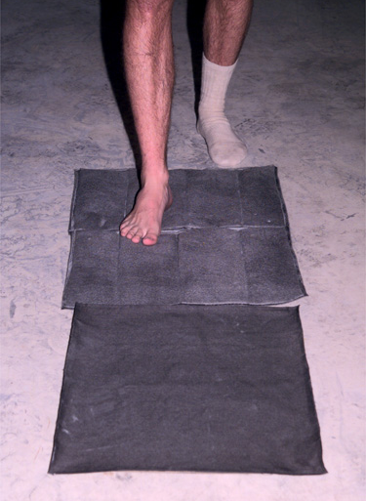
G. SDS Mat
Table 9. Results of ‘Litter Decon’ Cut-Out Procedure.

Personnel | Pre-exposure | *Ensemble | Contamination | Time Through Line (min) | Decon (cutter) Team
Carter | None | JSLIST | Clean | 16 | A
McDonald | None | " | Clean | 13 | A
Woods | None | " | Clean | 18 | B
Peterson | None | " | Clean | 20 | B
Carter | None | " | Clean | 12 | A
McDonald | None | " | Clean | 12 | A
Woods | None | " | Clean | 13 | B
Peterson | None | " | Clean | 13 | B
 |  |  |  | Avg. 14.6 Min
Decon Team A | Cutter Team A |  |  | No Iteration Times Taken
Wilkins | None | Flt. Suit/BR gloves/Sk/Bt/M45 w/BR Hood | Clean
Harty | None | " | Clean
Sasnicki | None | " | Clean
Mummert | None | " | Clean
Decon Team B | Cutter Team B
Swanson | None | Flt. Suit/BR gloves/Sk/Bt/M45 w/BR Hood | Clean
Voight | None | " | Clean
Nettleton | None | " | Clean
Maddocks | None | " | Clean
Decon Result (i.e. 'clean'):
w/o cutters 100%
 |  |  | w/ cutters 100%

Figure 7. The following photo set (Figure 7a-g) depicts the Litter Decon cut out.
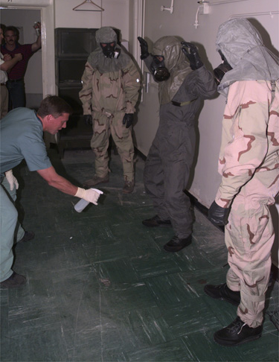 | 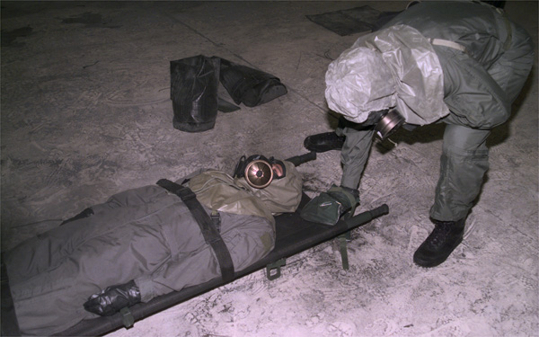
A. Tinopal Application | B. M295 Application
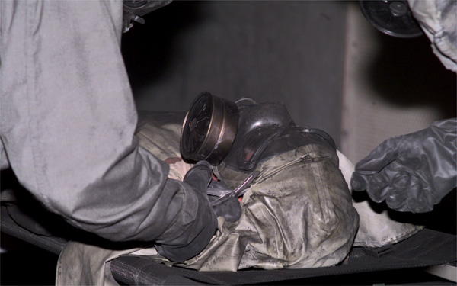 | 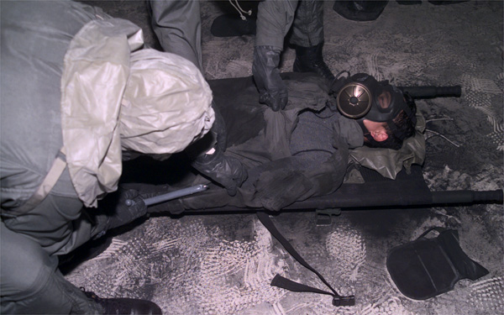
C. hood removal | D. Outer Garment removal
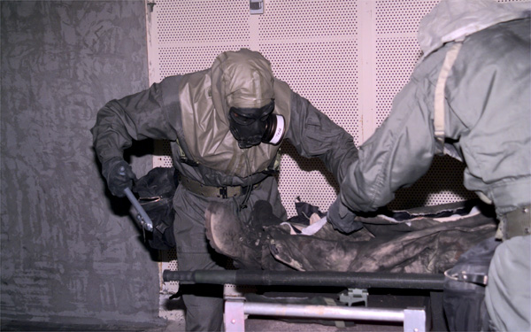 | 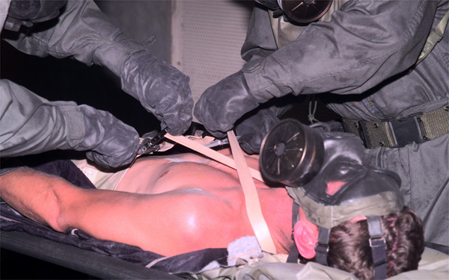
E. Boot Strap Removal | F. Trouser removal
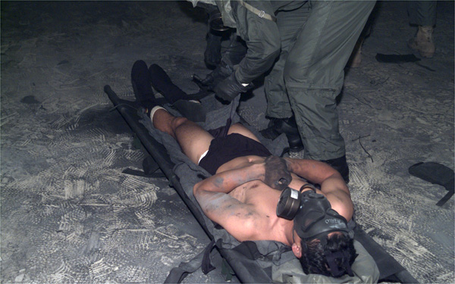
G. Removal of CPU

Discussion
Clearly, these procedures proved to eliminate liquid cross contamination during clothing (decon) removal. This study did not attempt to prove minimization of adverse effects of liquid off-gassing (vapor hazard). To ascertain whether these procedures provide complete protection to the individual during the decon process, individuals would have to be: 1) exposed to a liquid challenge simulant with low vapor pressure that is proven to be absorbed/neutralized by one of the dry decon technologies carried by NSWDG, and 2) monitored for both liquid and vapor exposure during the procedures. The assumption was made during this study that the decon technologies used would neutralize the agent and minimize off gassing.

An additional consideration that must be addressed is the possibility of off-gassing from the dropped equipment. It is assumed that the PPE will be contaminated during the cutting procedure and will off-gas throughout the period of decontamination. With the possibility of frequent wind shifts this would be an issue. Also, enclosed areas with minimal air circulation would only serve to increase the concentration of hazardous vapors within a given area. These issues may be minimized by the utilization of decon solutions/powders in the PPE drop areas (equipment bags or mask drop bags). Obviously, flow, direction and length of the decon line can be altered to minimize these effects.

The design of the procedures and success of the associated training for these procedures is reflected in the consistency of time required (when comparing all iterations) for each man to be successfully cut-out, regardless of ensemble. There was noted statistically significant improvement (from 14.8 +/- 1.5 to 10.5 +/- 1.5 minutes) in the time required to perform a two-piece cut-out procedure (comparison of times required from Gortex/CPU to Type VII cut-out, respectively).

Figure 8. Per-man iteration times for all ensembles.

One-piece procedures were consistent (ranging from 10.9 to 12.6 minutes, 11.6-minute average) and no statistically different times were obtained. Litter decon cut-out procedures utilized two distinct cutter teams (A and B). Each team (alternating 2 procedures at a time between A and B) performed a total of four cut-out procedures. Teams A and B displayed (statistically) significant improvement (11% and 32%, respectively) in the #3 and #4 iteration times (as compared to #1 and #2 iteration times) required to extricate the patient from his protective gear. Iteration times for 8 man teams were consistent as well, ranging from 37 minutes to 44 minutes. These times were determined by marking time from the first crewman’s step into the decon line until the last man removed his mask. In the case of repeating the FRIS/CPU ensemble (with CPU laundry tags to a without CPU tag status) cut-out, the team iteration time was reduced by 10%, representing a good example of the minimal training required to raise confidence and efficiency rate in the procedure. Together, these results suggest that the NSWDG cut-out standard operating procedures are very consistent in design, and allow, through a minimal hands-on training investment, a valid technique in expedient removal of contaminated clothing (regardless of ensemble) from an individual, while preventing any liquid cross-contamination and further harm to the individual as a result of the procedures.

